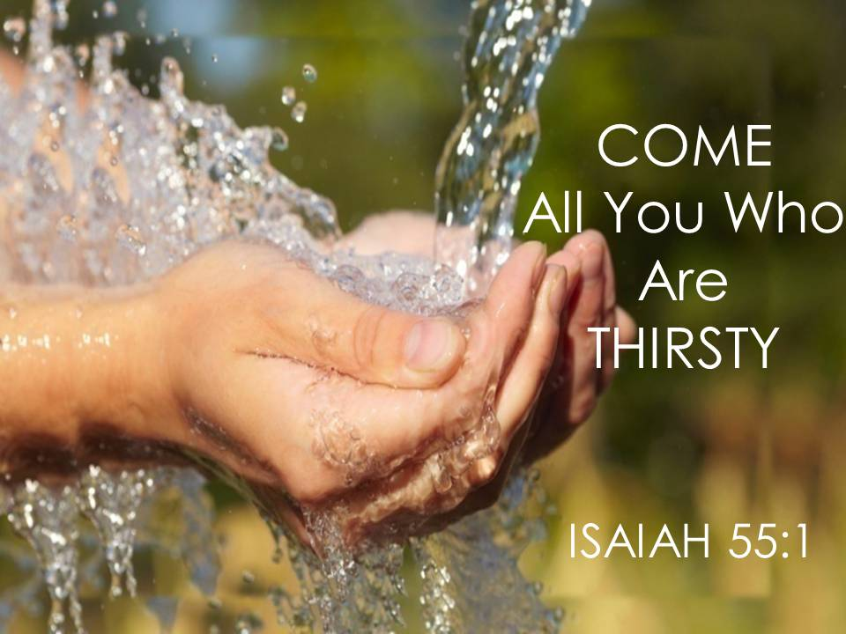

THAT YOU MAY LIVE
A sermon preached by
Rev. Dr. Randle R. (Rick) Mixon
Lake Avenue Baptist Church, Rochester, NY
Sunday, June 21, 2026

Text: Psalm 63: Isaiah 55:1-9

God of steadfast love, Imagination of the ages, you offer to all that world where all thirst is quenched, all the hungry are fed, all strangers become family. Thanks be to you! Amen.

“Life is a banquet, and most poor suckers are starving to death!” So, quipped Auntie Mame to her timid secretary, Agnes Gooch, in the beloved novel, movie, and musical by Patrick Dennis. Of course, the flamboyant Mame is trying to convince Agnes that, with just a bit of a makeover, she can fill in for her double-booked employer at a glamorous social occasion. Agnes is not so certain, but Mame encourages her with this well-known quotation. The humor notwithstanding, there is truth in Mame’s proclamation. “Life is a banquet, and most poor suckers are starving to death.” And if they’re not exactly starving to death, they may still be missing out on the best life has to offer.

Mame’s glamorous existence seems larger than life and Gooch’s is especially restricted. Still, there is a balance to be found in which we might truly revel in the wonder and beauty of life. I doubt that the Psalmist or Isaiah would have quoted Patrick Dennis, but it seems to me there is common ground. The Psalmist sings with joy and thanksgiving, “Because your steadfast love is better than life, my lips will praise you. So, I will bless you as long as I live; I will lift up my hands and call on your name.” And, speaking for God, the prophet proclaims, “Listen carefully to me, and eat what is good, and delight yourselves in rich food. Incline your ear and come to me; listen, so that you may live. I will make with you an everlasting covenant…” Life is a banquet and all are welcome – Auntie Mame, Agnes Gooch, you, me, everyone who hungers and thirsts.

Friends, I realize that when so much of the press and social media is full of tragedy, abuse, oppression, duplicity, incivility, hate, and just plain unkindness, it may be that a little reassurance is in order. I think here of the old hymn, “Be Not Dismayed (God Will Take Care of You).” Maybe that’s the message we most need to hear in these troubled times, the word that emerges when we go to our closets to pray. Even if it doesn’t seem so at the moment, we need reminders that life is a banquet and God will take care of us.

But here’s the catch, we will only discover these things when we turn to God. Turning to God is fundamental to our spiritual practice. I’m sure you have heard me say before that the point of letting something go or giving something up for the sake of our spiritual centering is to clear away whatever gets in between God and us. It is not to simply give something up as a sort of punishment for sin or because tradition tells you you should. It’s to eliminate the clutter so you can “Incline your ear, and come to [God]…”, so you can better “listen [to God]…that you may live.”

“Listen, so that you may live.” But this may be easier proclaimed than practiced. Many competing voices call to us, pull at us, make demands on us. In commenting on this text, Daniel Debevoise, writes, “…Isaiah’s words are not the only offers we hear. We live in the midst of constant promotion. Everywhere we turn we are bombarded with offers and enticements to fill every imaginable want and desire. Even if we do not need anything, it is easy to be convinced we really want something: a new car, a new computer, a glamorous career, a bigger house, a youthful appearance. However, the offers are false. They promise to satisfy but turn out to be wasted calories without any nutrition. Any way of life that turns us away from God is a way of life that leads to our starvation and death (Daniel M. Debevoise, Feasting on the Word, Year C, Volume 2: Lent through Eastertide, p. 76). This is a hard but important lesson – “Any way of life that turns us away from God is a way of life that leads to our starvation and death.”

Life is a banquet alright, but we might have to choose between Auntie Mame’s table and God’s. There may be a certain abundance at both, but which is more likely to be truly life sustaining in the end? “Why do you spend your money for that which is not bread, and your labor for that which does not satisfy?” I remember speaking with a young Buddhist practitioner who had a responsible position with a top Silicon Valley tech company. Among other things, we talked about spirituality in our current environment. As a key element to my ministry, I have tried to help congregations address what I see as a very real concern for spiritual well-being among the people in their community. In this conversation, it was both affirming and challenging to hear him insist, as a young man from a different tradition, that this concern is valid. Charming, bright, and successful as he is, he believes that any number of young people having success in Silicon Valley will come to a day when they wake up and ask, “Is this all there is?” Wonderful as Mame’s banquet may be, in the end it does not offer the spiritual sustenance that is essential to our ultimate well-being.

Hunger and thirst for God is deep-seated, built into our very nature. As Augustine, wrote centuries ago, “our hearts art restless till they rest in [God].” As we are made in the image and likeness of God, there is an eternal pull to turn toward God to follow God’s way and do God’s will. We may have differing awareness of our hunger and thirst, of our need for God, but it is there, somewhere deeply embedded in the very core of our being.

Drawing on climate images, Daniel Debevoise compares our thirst for God to the importance of good hydration. In humid climates we usually know we’re thirsty as we sweat away the water we have taken in, but in dry climates we are not always so aware. Debevoise writes, “…where humidity is low, you may be thirsty and not even know it…so you drink a little water as often as you can.” He notes that “In Grand Canyon National Park there are signs strategically placed along the trails that remind you to stop and drink water. ‘Stop! Drink water. You are thirsty, whether you realize it or not’” (Debevoise, op. cit,. p. 74). This seems like good advice, one from which we could all benefit – Stop! Drink! You are thirsty whether you realize it or not! “Seek God while God may be found, call upon God while God is near…listen, so that you may live.”

“Ho, everyone who thirsts, come to the waters” and isn’t that all of us at some time or another, at some level or another? Eventually, don’t we find ourselves, singing with the Psalmist, “My whole being desires you like a dry, worn, waterless land. My soul thirsts for you”? Don’t we all hunger and thirst for the holy, even if there are varying degrees of awareness? Initially, Lindsay Armstrong affirms our need for God, but she also wonders how many recognize and embrace it. “If there is anything we need more of in our XXL society,” she writes, “it is more joy and pleasure in God. Loving God more than life still feels foreign to most of us; our desire for God has rarely been so full-bodied that it feels like hunger or thirst” (Lindsay P. Armstrong, Feasting on the Word, Year C, Volume 2: Lent through Eastertide, p. 84). It is tough territory to turn ourselves over to God when there are such powerful counterclaims on our commitment, on our time and energy. There are so many banqueting tables to which we might pull up a chair. There is so much to explore and experience. Why should God have first claim on our lives just because she made us and loves us and deeply desires to be connected to us?

For some of us it may be difficult to find or to recognize or to admit that embedded longing, our own deep hunger and thirst for God. Armstrong continues, “For those who worry they are not good enough or who feel isolated or on the outskirts of ‘real’ Christian community, Psalm 63 invites us to start with whatever longing we do have. Whether we genuinely desire to know and enjoy God more, whether we want to desire such a thing, or whether we simply know discontent, restlessness, boredom, or a breaking point, God takes the small and changes the world with it” (Armstrong, op. cit., p. 84).

That’s the way of it is with God. God takes the small and changes the world with it. An important aspect of our faith journey is to engage in the discipline of turning toward God, of opening ourselves to the ways in which God is present and moving in our lives and in the world around us, to let ourselves be that small thing with which God may change the world. We can sing with the Psalmist for all to hear, “how mighty are your works; your constant love is better than life itself…” We can stand with the prophet and proclaim to the whole wide world, “Ho, everyone who thirsts, come to the waters; and you that have no money, come, buy and eat! Come, buy wine and milk without money and without price.” Good news for troubled times and don’t we need it? Listen to God that you may live – you and me and all the world. Amen.

