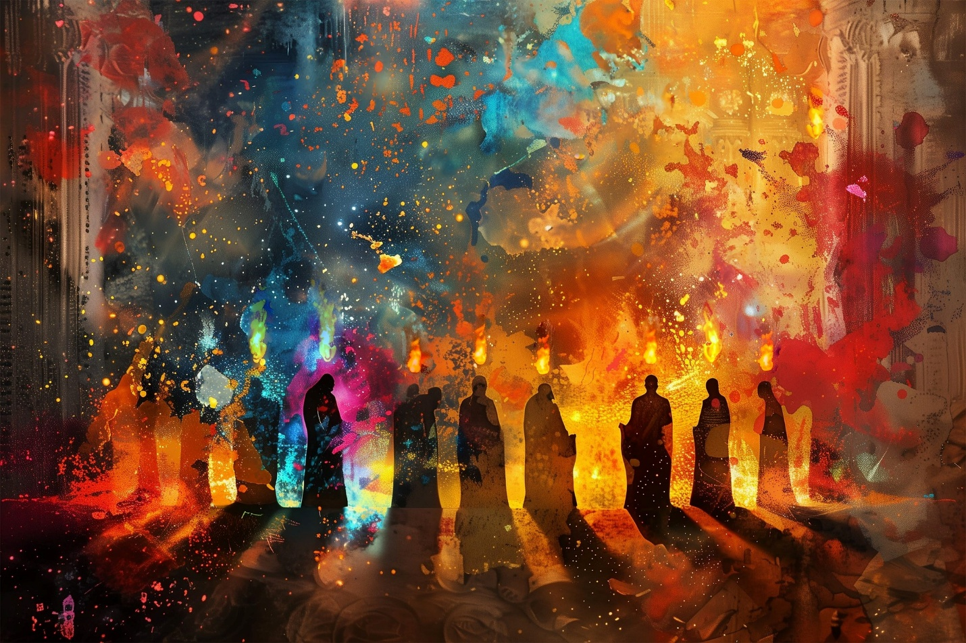

HOLY LAUNCH PAD!
A sermon preached by
Rev. Dr. Randle R. (Rick) Mixon
Lake Avenue Baptist Church, Rochester, NY
Sunday, May 24, 2026

Text: Acts 2:1-8

Recently, many of us watched with fascination as the Orion rocket was launched from the Kennedy Space Center at Cape Canaveral, Florida, carrying four astronauts on a journey around the moon. For some, this launch reminded us of similar occasions in the past that carried both scientific equipment and human subjects to explore space beyond our small blue-green planet. Even with our rich memories of past launches, this one was still captivating as we observed once again the explosive power it takes to hurtle a rocket into outer space; and then in turn listened as the astronauts, against the vast backdrop of stars and galaxies, with humility and grace affirmed the importance of life on our small planet. I don’t know if any of you have had the opportunity to observe a launching first-hand, but I can only imagine how much more impressive such an occasion would be in real life, given how it exhilarates on the small screen.

The title for this sermon was inspired by a phrase from a commentary by David Gushee who wrote, “…the pouring out of the Holy Spirit upon the church is both the sign and instrument of the launch of the church’s mission” (David Gushee, Feasting on the Word: Year A, Volume 3, p. 14). Holy launch pad! “The launch of the church’s mission.” Even though this was something of a passing comment in Gushee’s reflection, it struck me that it captures the spirit and truth of Pentecost, at least the way Luke lays it out in today’s Ancient Word. There are other dimensions on which we could focus, but the idea that the church is born on this day, is dramatically launched to spread the good news to the ends of the earth, speaks to me.

First, the setting – Jews from all over the world were gathered in Jerusalem for Shavuot or the Feast of Weeks. It was one of three major celebrations which Jewish males were expected to attend in Jerusalem. It was held 50 days after Passover to mark the beginning of the spring harvest. Thus, the association with Pentecost which comes from the Greek word for 50. For Christians, the celebration is 50 days after Easter.

The streets of the old city were packed. It was as if the whole world had gathered to celebrate. So, the setting was prime for what was to transpire, as if it might have been part of some great plan.

However, Jesus’ disciples were huddled in hiding, unsure of what was to come next for them. The past month and a half had been a roller coaster ride. The bottom was Jesus’ trial, execution, and burial. The top was the empty tomb and Jesus’ amazing appearances among them. But then that physical presence of the risen Christ turned out to be temporary. They had quizzed him, “Christ, is this the time when you will restore the kingdom to Israel?” They were still hopeful that God, through the Messiah, would transform their lives by driving out the hated Romans and their collaborators, effecting a way of life that would lift the people, meeting their wants and needs.

But that was not to be. “It is not for you to know the times or periods that God has set by Their own authority.” More uncertainty. What were they to do? Jesus instructs them to wait in Jerusalem for what has been promised – “…you will receive power when the Holy Spirit has come upon you; and you will be my witnesses in Jerusalem, in all Judea and Samaria, and to the ends of the earth.” Something about that certainly sounds grand but it must also have been confusing to those who had not yet had the radicalizing experience that was to come. Try to imagine what it must have been like for those first followers who had been through so much in such a short time to hear these words and trust this promise.

Finally, they had watched him rise from earth, lifting off from his own launch pad toward his heavenly home. Then the heavenly word as he disappeared into the clouds. “…why do you stand looking up toward heaven? This Jesus, who has been taken up from you into heaven, will come in the same way as you saw him go into heaven” (Acts 1:6-11). Is that a reassuring or even hopeful word? I imagine their thoughts and feelings were jumbled as they made their way back to the city. Willing to wait, yes, but unsure of just what they were waiting for, what the future might hold. If there was any celebration, it must have been subdued.

So, early morning. They were just waking up when there was a great disturbance in their universe – wind blowing this way and that, tongues of flame darting here and there, garbled speech. For the moment it felt like complete chaos. Was all this drama better than waiting, wondering, and worrying? They weren’t sure. Nothing was immediately clear.

But as the morning progressed, the power of the Spirit began to settle on them. They realized they were actually speaking known languages, enabling them to communicate with those on the street gathered from all over. A sense of elated confidence grew among them as they moved among the crowd, sharing the good news of Jesus, the Christ and his power to transform their lives.
I like what Jhanderys Dotel-Vellenga observes about this text. She writes, “The Spirit does not force everyone to speak alike. Rather, the Spirit makes it possible for us to understand each other in the midst of our differences. In a world where there are so many barriers: language, culture, experiences, politics, etc., this is profoundly necessary.” It is vital that we work to understand one another given the deadly divides that threaten us today
Dotel -Vellenga continues, “The Spirit builds bridges. Being filled with the Spirit also means learning to listen. To pay attention to the stories of other people. To make space for different voices to be heard and valued. Understanding each other is not always easy. It requires patience, humility, and love. But that is where the Spirit continues to work. Perhaps today the call is not to talk more, but to be better listeners” (Jhanderys Dotel-Vellenga, “Learning to Listen,” 5-23-2026, https://d365.org/devotions/learning-to-listen/).

For the first disciples, it was a new day in more ways than one. Increasingly their mission became clear – “…the pouring out of the Holy Spirit upon the church is both the sign and instrument of the launch of the church’s mission.” Holy launch pad! Like a rocket ship stuffed full of intrepid adventurers, those first disciples were launched with power into a new way of living in the world that they had not imagined before that morning.

Whether Acts 2 is a factual account or a mighty myth or some combination, I believe there is a word here for us. The big question looming is what is the church’s mission? What is the church universal tasked to do in the 21st century? What is the calling of Baptists around the world, in the ABC-USA, the Rochester-Genesee Region, at the pointed meeting of Ambrose and Jones Streets?

Now, please don’t get upset when I tell you that I do not have the answer to those nagging questions. This is something for us to explore together. Once again, we are living in uncertain times. Like the first disciples, we find ourselves waiting, wondering, and worrying about the status of the church and what the future holds. What is the good news that characterizes our mission today and who needs to hear that good news? Not having the answer does not mean that I don’t have any thoughts about what might resonate. I imagine you do, too.

Above all, love. In the words of the old song, “love makes the world go ‘round.” There are times when we know deeply the truth that God is love. If, as we affirmed a couple of weeks ago, it’s God in whom we are grounded, in whom we live and move and have our being, is it a stretch to say that we are grounded in love? Can we say in good faith that it is in love we live and move and have our being? How might our lives be different if we began and ended our days by affirming this truth? We are nothing without the love that gives us our very life.

Breathe on me, Breath of God,
fill me with life anew,
that I may love the way you love,
and do what you would do.

As a starting point, how might we walk through this world if we understood ourselves to be made in the very image and likeness of love? Now you know that I am not talking about sentimental love. I am speaking of the love expects peace and the well-being of all creation, that demandss justice and equity, that love that wants to turn the world right side up, making real the abundance of life God breathed into everything at the beginning.

Week after week we acknowledge that we live in tough times. So did those first disciples. They were fearful and frustrated, angry and exasperated with the social order and political reality of their day as are we. But whether it was an earthquake, tornado, fire, or the insistent voice of God speaking to the essence of their being, those disciples discovered something that day that did indeed launch them on a sacred mission to sing God’s praise, to tell God’s truth, to walk Jesus’ way openly and joyfully. Holy launch pad! May we receive the same powerful blessing of the Holy Spirit today!

Come down, O Love divine,
seek thou this soul of mine,
and visit it with thine own ardor glowing;
O Comforter, draw near,
within my heart appear,
and kindle it, thy holy flame bestowing.

Dotel-Vellenga reflects further on today’s text: “The Spirit moves, shakes, awakens. It breaks fear and kindles courage. There may not always be visible signs as at Pentecost, but that does not mean that the Spirit is not at work. Many times, the Spirit’s work is deep within: changing hearts, renewing strength, giving clarity, affirming righteousness. To be filled with the Spirit is to be open to this movement, even when we do not fully understand it. Today, perhaps, God is working in you more than you can see” (Jhanderys Dotel-Vellenga, “Arrival of the Spirit,” 5-22-2026, https://d365.org/devotions/). I believe that is so. God is at work in us always. The challenge is to open ourselves to that movement and be willing to go where it leads us.

The Spirit may not exactly be rattling our cages today, but she might just be unlocking the door that will set us free, free to explore more deeply what it means to be God’s children, the body of Christ, the people of the good news that love and life will always prevail. Truth that sets us free. Holy launch pad! The church’s mission – to join in building up and maintaining God’s Beloved Community on earth as in heaven. On Pentecost Sunday, once more we sing with the spirit

O let it freely burn,
till earthly passions turn
to dust and ashes in its heat consuming;
and let thy glorious light
shine ever on my sight,
and clothe me round, the while my path illuming.
And so the yearning strong,
with which the soul will long,
shall far outpass the power of human telling;
for none can guess its grace,
till Love create a place
wherein the Holy Spirit makes a dwelling.
Holy launching pad for a church on a mission! May it be so. Amen.

