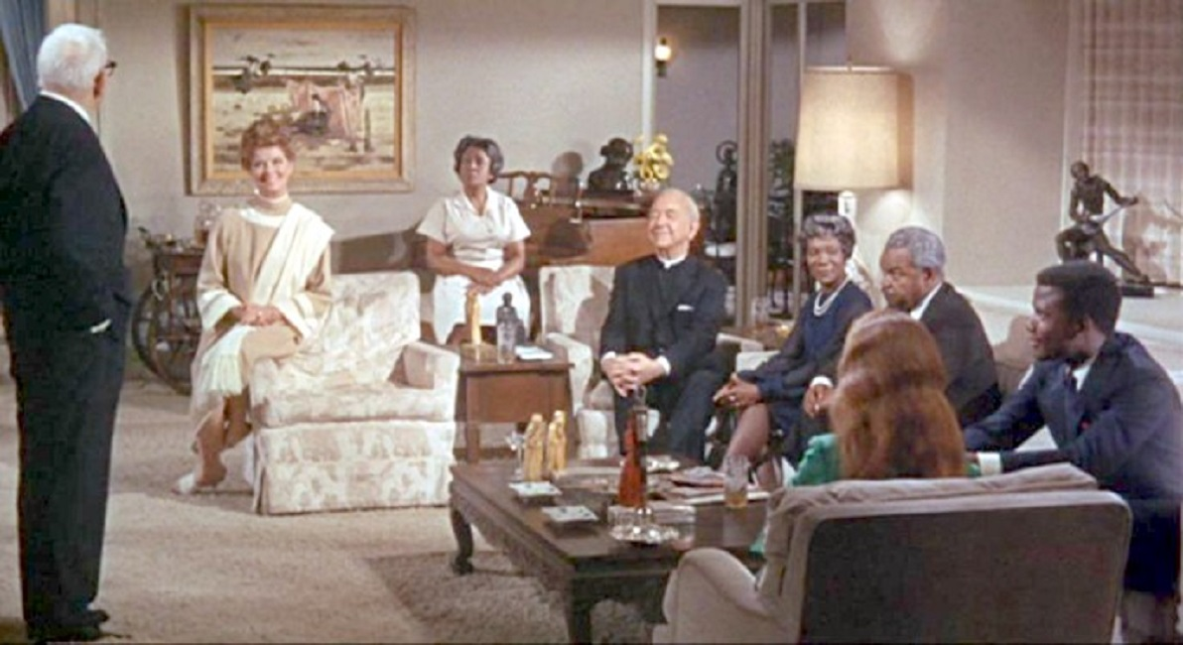

GUESS WHO’S COMING TO DINNER?
A sermon preached by
Rev. Dr. Randle R. (Rick) Mixon
Lake Avenue Baptist Church, Rochester, NY
Sunday, June 7, 2026

Text: Matthew 9:9-13 (NRSVUE)

Some of you surely remember Stanley Kramer’s classic 1967 film, “Guess Who’s Coming to Dinner?” Of particular note, it was the last film for iconic actor Spencer Tracy who died only two weeks after filming concluded. It also starred Katharine Hepburn who was often paired with Tracy on film and in real life. Another featured actor was a rising young star, Sidney Poitier. The romantic comedy/drama was controversial as one of the first major movie to treat the topic of interracial marriage in a positive light.

Tracy and Hepburn play upper middle-class Americans – he a retired newspaper editor; she an art dealer. The plot centers on their 23-year-old daughter returning from vacation with a 37-year-old widower as her fiancé. Not only has this relationship blossomed during a whirlwind 10-day romance in Hawaii, but the doctor, played by Poitier, is black. The differences in age and experience are raised, of course, but the real challenge to her liberal parents is her finance’s color. The mother (Hepburn) comes to accept the relationship as does Poitier’s mother, but both fathers struggle to come to terms with the young couple’s commitment. They both raise their concern that in the mid-1960s interracial relationships were not socially acceptable. Of course, this argument is partly a smokescreen for the racism that affects them both – an older black man with a young white woman is just not done. There are so many degrees of difficulty! In fact, when the film was made there were still 17 states that outlawed miscegenation. Filming ended shortly before anti-miscegenation laws were struck down by the Supreme Court in their historic ruling in Loving v. Virginia on June 12, 1967.

I bring up this movie this morning partly because it provided a clever title for the sermon but more importantly, like today’s gospel text, it raises questions about radical hospitality, questions that run all through scripture, Hebrew and Christian alike. Just who is welcome and at what tables? Scholars have long recognized the significance of table fellowship and the controversies around it as crucial to Jesus’ life and ministry.

Poitier’s Dr. Prentice is a highly principled man. He represents a kind of ideal. He appears to have no drawbacks except for the color of his skin. Still, he makes a decision that he will not marry the woman he loves if all four parents do not agree to support them. The entire blended family – parents and children must find welcome at the same table if the young couple are to thrive in married life. The challenge to be truly inclusive comes to each of us at one time or another and we must decide.

Now I realize there are limits to comparing these two stories, but the question of who is welcome at our tables and especially at this communion table spread before us today is worth considering. Do we ever grow so completely beyond our inherited and cultivated prejudices that we can say all are welcome and truly mean all? I believe the question is not easily answered.

Jesus was walking though his home base of Capernaum and there on the corner was Matthew, the tax collector, sitting at his collection station. Were they total strangers or had they encountered one another as they moved around town? Is Matthew someone who has heard Jesus teach and seen Jesus heal and been filled with longing for something more in his life? It even entered my mind that he could have been one of that group that grew up with Jesus along the shores of the lake, sharing hopes and dreams and wrestling with what it meant for them to be children of the living God. I even imagined he might be from a particularly poor family without means of survival and had given himself over collecting tariffs and taxes in a desperate effort to provide for himself and his family. We know survival in that time and place was precarious and many did not make it. Maybe he was just waiting for Jesus to come along and liberate him from the shame of his hated role and all the disdain and humiliation he suffered on a regular basis.

All we know from the text is that this was another of these seemingly simple encounters when Jesus said “Follow” and the invitee said “Yes.” We get a lot more detail about such a transformation in Luke’s story about Zacchaeus, another tax collector changed by coming into contact with Jesus (Luke 19:1-10). Is it Jesus’ charismatic character that draws them, or is it their readiness for something new in their lives, or is it a hunger for richer fare than their daily diet of double dealing and enduring their neighbors’ animosity, or is it some combination of all these things? For whatever reasons, both Matthew and Zacchaeus are ready to receive the invitation and respond with an emphatic “Yes”.

It’s indicative of the importance of table fellowship to Jesus’ ministry that the calling of both is followed by a meal. It seems meaningful that once one has claimed discipleship they sit down to dine together. How often has this been true for you? A significant deal, or encounter, or transformation, or commitment has been sealed or celebrated with a meal. There is something intimate and life-giving about gathering at the table. Parker Palmer argues that it is essential to building up Beloved Community.

It’s not entirely clear in the text who invites whom to dinner. Does Jesus invite Matthew home to his place in Capernaum? Or does Matthew throw a celebratory meal at his house like Zacchaeus? As Mark and Luke tell this tale they name the tax collector Levi, and the meal is at his place. Either way the question of an unexpected guest is an important one. Guess who’s coming to dinner? If Matthew is to dine at Jesus’ place, what is a tax collector doing in the home of a rabbi? If Jesus is to dine at Matthew’s, what is a religious leader doing breaking bread with a publican, a hated collaborator with Roman rule and Herod’s oppression? Either way, someone is sure to lose face in such a shame and honor culture.

Jesus and his disciples at table with tax collectors and sinners. The Pharisees, the ones who were protectors of purity at all costs, were nonplussed, though they were not quite brave enough to confront Jesus at this point. They quizzed the disciples instead. “Why does your teacher eat with tax collectors and sinners? How can you and he justify such behavior?” It clearly fell outside the boundaries of acceptable behavior and in the eyes of the Pharisees rendered them all unclean, unfit to participate in the religious practices of which the Pharisees were so protective.

The text doesn’t report how the disciples responded, but when Jesus got wind of these Pharisees who questioned his methods and ministry, he had something to say. “Those who are well have no need of a physician, but those who are sick…For I have not come to call the righteous but sinners.” I love this response. It is my favorite of Jesus’ comebacks to officious folks who question what he’s doing. I do have some difficulty in equating sin and sickness. In this day and age when we are focused on the power of labels to liberate or stigmatize, sinners and sickness too often take on a negative connotation. But if, as I understand it, sin is not bad behavior but anything that gets in between us and God, that keeps us from focusing our lives on the One in whom we live and move and have our being, then I can understand the need for a little saving. I can accept that Jesus has come for one like me, along with a whole lot of others who are in need of assistance living fully into what it means to be a child of God.

The Pharisees were just as much in need of Jesus’ healing as the tax collectors and sinners. The crucial difference was that they could not see their need. Their self-righteousness, their sense of superiority, their failure to grasp the good news of radical hospitality got in the way, got in between them and the Great Physician, the healer of our every ill. It’s not that Jesus would not have welcomed any of them who chose to repent and relinquish their judgmentalism to the table. There’s plenty good room! Draw the circle wider. Guess who’s coming to dinner? Nicodemus and Joseph of Arimathea and they’re bringing a few friends with them. They have seen in Jesus’ life and ministry their own need of the physician who heals all unrighteousness and failure to love as God loves. “Go and learn what this means, ‘I desire mercy, not sacrifice,’” he reminds them of the prophet Hosea’s powerful message.

There is a stanza in today’s opening hymn that sadly we did not sing. Frederick Faber wrote:

For the love of God is broader
than the measures of the mind;
and the heart of the Eternal
is most wonderfully kind.
But we make this love too narrow
by false limits of our own;
and we magnify its strictness
with a zeal God will not own.

Gabriella Conklin, in commenting on the hymn and, indeed, today’s text, has written, “It is tempting to think of mercy as something that has limits—something that needs to be measured out carefully. Some of us may even wonder if there is enough grace for us, or if we have somehow gone too far to receive it. This hymn reminds us that the idea of limited grace and mercy couldn’t be further from the truth. There is a wideness in God’s mercy, “like the wideness of the sea.” It is not small or scarce, but expansive beyond what we can imagine. There is welcome for the sinner, healing found in Christ, and grace enough not just for a few, but for ‘thousands of new worlds.’ There is room, more room than we tend to believe. God’s mercy is not something we must compete for or prove ourselves worthy of. It is already given and given abundantly. Today, we are invited to trust in the wideness of God’s mercy—to receive it for ourselves, and to believe that there is more than enough to go around.”

Heal us from our failure to offer mercy and compassion when and where it is most needed. Guess who’s coming to dinner? Remember this celebratory meal? “‘Bring quickly the best robe, and put it on him, and put a ring on his hand, and shoes on his feet. And bring the fattened calf and kill it and let us eat and celebrate. ²⁴ For this my son was dead and is alive again; he was lost and is found.’ And they began to celebrate” (Luke 15:11-32). The father is delighted with the return of his prodigal son. Those who know their need and own it find the embrace of the Waiting Father, the healing of the Great Physician.

But the older brother was having none of it. Like some of the Pharisees Jesus encountered, he could not let go of his rigid self-righteousness long enough to celebrate that his own flesh and blood, his brother had made his way home, the lost found, the dead revived. We don’t know if he ever came around to joining the party but we do know the invitation was extended as it always is. The challenge for us is that it is extended to the least likely characters we can imagine – sinners and tax collectors, scribes and Pharisees, those who are addicted and those who are free spirits, those who are hungry and those who are overfed, those who are penniless and those who are wealthy, scoundrels and saints, professors and line cooks, sanitation workers and art dealers, cheats, liars and dissemblers that occupy seats of power and community organizers and union stewards. You get the picture.

Guess who’s coming to dinner? We can’t always say for certain, but we do know who’s invited – everyone, yes, every single one. And to be honest, this may be a challenge for us. Somewhere deep inside we harbor hope that so and so is not included, that that one won’t make it, that surely there’s no room for them. It’s difficult, probably impossible, to grasp fully the mind of one who desires mercy and not sacrifice, who includes the whole creation, everyone and everything in whom and which the Holy One delights, all of it. This amazing grace, this infinite blessing, this capacity for compassion is beyond my pay grade, but it does lure me into its vision of who and what we could be if we were to hear the call of the physician to follow into healing and wholeness, if we could imagine a table big enough to include all, if we could see the possibilities of Beloved Community. Open our eyes, engage our minds, enlarge our hearts. Give us ears to hear when the invitation is extended and hearts ready to say “Yes, we will follow.” Amen.

