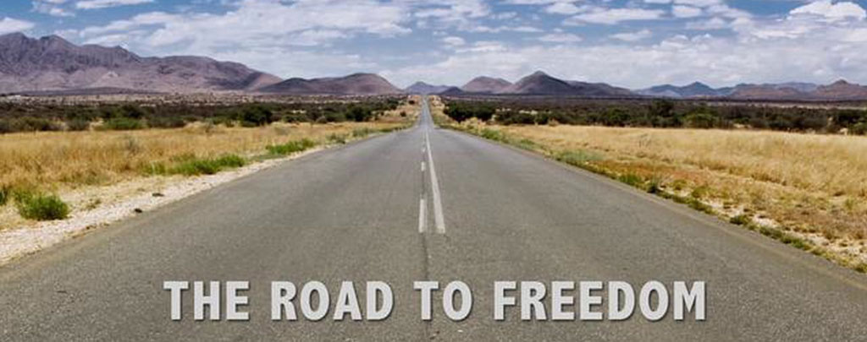

IT’S A LONG ROAD TO FREEDOM
A sermon preached by
Rev. Dr. Randle R. (Rick) Mixon
Lake Avenue Baptist Church, Rochester, NY
Sunday, July 5, 2026

Text: Galatians 5:1a, 13-26

O God, we pray this day with heavy hearts for our nation. We are a divided people. We are a people in need of reconciliation. We are a people in need of speaking truth, doing so always in love. We confess our impatience and our unwillingness to listen to one another. We seek powers of this world to solve our problems, yet they are imperfect and temporary, shallow and in need of Your direction. We look to You, O God, to order our paths and lead us forward. By the cross of Jesus and in the power of the Spirit, we pray. Amen.

It’s a long road to freedom and the USA has been traveling that road for 250 years or more now. Trumpeted claims to the contrary, the sad truth is that we have not yet reached the goal. Sometimes it feels like two steps forward then one step back and sometimes those steps seem reversed. We live in constant tension between the promise of freedom and the realities of life in this country. This tension is not new. It is built into the founding documents that envisioned what a free people living in a free society might look like but failed to fully follow through. The founding fathers (and yes, they were all men, wealthy white men to be more precise) did risk “lives, fortunes, and sacred honor” in defense of their limited dream of what a free people in a free land might be. But it was a severely limited dream.

“All men are created equal” they claimed but we know that “men” was narrowly defined as white male property owners and did not include such as poor white men, men of color, women of any sort, slaves, or indigenous inhabitants of the land. The founders’ great innovation was to claim that a group of citizens might free themselves from the tyrannical rule of monarchs and manage their own lives. This was a radical claim in the middle of the 18th century. Though limited in scope, it did mark a significant step forward toward freedom.

The long, winding road the people of the USA have traveled over the past 250 years has been toward living more fully into the freedom that the dreams of the founding fathers planted in our hearts. Their vision of a free people in a free land caught on and has been expanded over time to include all sorts of people with all sorts of identities. Increasingly inhabitants of the “land of the brave and home of the free” realized that they, too, were entitled to the recognition of their “unalienable rights to “life, liberty and the pursuit of happiness.” Why shouldn’t we all be included, we asked as we worked to make the dream a reality?

Of course, there was resistance all along the road from those who wanted to reserve the privileges of citizenship for themselves. People of color were seen as less than human. Women and children were considered property. Clearly God had ordained an elite class of beings to bring order and control to society. Variations in gender orientation and sexual identity weren’t even up for consideration until the mid-20th century. I’m sure there are other areas of resistance you can call up. The net result is that we live in this tension. There have been periods in which hope shone brightly, and the promise of freedom seemed attainable. Then there have been times we have been mired in despair that the road to freedom will ever lead us there.

So, as we are invited to celebrate the 250th anniversary of this nation, many of us find ourselves with hope eroded and lives leading toward despair. Following the misguided views of the malignant narcissist and convicted felon who currently occupies the White House, we have watched the promise of freedom disappear for many as myriad hard-won gains for the common welfare were destroyed. Our government is being held hostage to a reactionary way of life, and we are lurching toward authoritarian rule. There are moments when it seems like there is nothing we can do to stop this juggernaut. But as people of faith are we not tasked with being holders of hope – for ourselves, our neighbors, indeed for all creation? Another tension in which we dwell.

Commenting on the times, Ken Gray writes “This weekend marks the 250th anniversary of the signing of the Declaration of Independence. It’s sad that what should have been a great celebration of liberty and self-governance has been tempered instead by forces in our culture and currently in government who choose to squelch those very things. Though our current situation seems dire indeed, we should be reminded that liberty has always been more aspirational than actual, and the full flourishing of human beings must always rely upon more than political will and governing documents.

This desire for the full flourishing of human beings brings us to today’s text. What’s the difference between Paul’s view of freedom and that of the founding fathers or of today’s political leadership, for that matter? Indeed, what is freedom? What is it to you? What do you think when you hear the word? Since we claim to live in the land of the free and we tout that term freedom, how universally are our citizens truly free of everything that binds them, holds them down, denies them opportunity, safety, and well-being? And what does it mean for our national identity as the self-proclaimed leader of the free world in days like these when we seem headed toward our own brand of authoritarianism?

As today’s text tells us, freedom is a great gift, a gift of God in Jesus Christ. Paul writes that Christ has set us free from every slavery – to masters, to false gods, to constricting legalism, to whatever binds us in any restrictive and negative sense. True, the journey to freedom may be a long and arduous one, but it brings one of God’s great gifts to our human being, if we can find our way. Many years ago, when she was still one of the Medical Mission Sisters, Miriam Therese Winter, the great hymn writer and liturgist penned these words:

It's a long road to freedom,
A winding steep and high,
But when you walk in love
With the wind on your wing
And cover the earth
With the songs you sing
The miles fly by.

It may sound a bit naïve to our ears today, but I think what she has written fits well with what Paul is saying in the 5th chapter of his letter to the Galatians. “For freedom Christ has set you free.” Freedom, yes, but it’s a new order of freedom. For Paul, and for anyone who would claim the freedom Christ offers, freedom is not license. It is not just freedom from, it is also freedom to. And not freedom to do anything I damn well please. Remember when you used to get in a debate or an argument with your siblings or friends or your parents or teachers, and you would throw out the clinching argument. “I can do it if I want. It’s a free country.” In retrospect that’s a rather lame argument for license and self-indulgence and it seems that it has become common practice in today’s social and political environment.

Ken Gray again observes that in the USA today “…there is plenty out there to be vigilant about. Dangers to our physical safety and threats to our moral and spiritual well-being are all around us. There is rampant gun violence—our children live with the ever-present danger of being gunned down at school. There are the outright lies that pervade our public discourse—we live in a ‘post-truth’ generation of ‘alternate facts.’ Our friends and neighbors are tracked down on our streets, captured violently, and then carted off to parts unknown. While we are told we cannot afford to provide medical insurance or sufficient food to our fellow citizens, the oligarchs openly, brazenly engage in corruption, grifting, and expensive boondoggles that enrich their own pockets. Our leader whines like an infant over not receiving a peace prize while bombing and threatening anyone who stands in the way of his avaricious appetite for conquest. And while we are told to live more simply and do without, our dear leader slaps his name on everything he can see, engages in self-aggrandizing vanity projects, and has gladiatorial cage matches on the White House lawn.”

Over against the challenges of the times, the point both the Apostle Paul and Miriam Therese Winter want to make is that there is a different sort of freedom available. That is the freedom to love. This is the new order of freedom, the freedom for which Christ has set us free – the freedom to love. In his letter to the Galatians, Paul tries to spell this freedom out concretely.

It is obvious what kind of life develops out of trying to get your own way all the time: repetitive, loveless, cheap sex; a stinking accumulation of mental and emotional garbage; frenzied and joyless grabs for happiness; trinket gods; magic-show religion; paranoid loneliness; cutthroat competition; all-consuming-yet-never-satisfied wants; a brutal temper; an impotence to love or be loved; divided homes and divided lives; small-minded and lopsided pursuits; the vicious habit of depersonalizing everyone into a rival; uncontrolled and uncontrollable addictions; ugly parodies of community. I could go on.

That’s a pretty ugly list of what freedom that leads to license produces. Doesn’t it sound all too familiar in the world in which we live today? The great irony is that many of these indulgences can actually bind us and eventually cheat us of real freedom.

But what happens when we commit ourselves to the new order of freedom in Christ Jesus. Or as Paul puts it:

But what happens when we live God’s way? God brings gifts into our lives, much the same way that fruit appears in an orchard—things like affection for others, exuberance about life, serenity. We develop a willingness to stick with things, a sense of compassion in the heart, and a conviction that a basic holiness permeates things and people. We find ourselves involved in loyal commitments, not needing to force our way in life, able to marshal and direct our energies wisely.

The feminist theologian Letty Russel reminds us that the spirit of Christ “leads to a new order of freedom, in which Christ has set us free to be for others…ministry is the response of each and every Christian to Christ’s call to freedom. In their baptism Christians are set free to serve now, in and through many communities and situations.” There is a delicious irony in being free to serve. One whose life is driven by love understands the joy inherent to this sort of freedom. “When you walk in love, with the wind on your wing…the miles fly by.” “For freedom Christ has set us free.” It is a new order of freedom – one characterized by compassion, care, service, and, above all, love. Each of us is free to choose that way for ourselves. How will you respond?

So, as we commemorate the 250th anniversary of the founding of the USA, we may want to celebrate, but these are tough times in our country and we’re not so certain we can celebrate or even want to. Under the country’s current leadership, we have taken a decided turn away from democracy. Is there sufficient room to celebrate as we also work to right the ship of state? I don’t know. The answer is not obvious; the way is not clear. We need to decide for ourselves as individuals and as a community how we will tackle the long road to freedom today.

As I wrote in this month’s newsletter, I do believe that it is essential for us not to give up hope of reclaiming the roots of our representative democracy. If we have the will, do we also have the capacity to grow beyond not only the stunted present in which we are currently mired but also beyond the limitations of our past? Before the recent unraveling, we were actively learning how to live into the lovely truth claims on which our country was founded. Can we still find our way there?

Abraham Lincoln appealed to the “better angels of our nature” and the apostle Paul reminds us that “For freedom Christ has set us free” (Galatians 5:1). But for both Lincoln and Paul, it’s that new order of freedom. It’s freedom that comes with responsibility to care for the well-being of our neighbor and the world in which we live. We are freed in order to love one another – openly, generously, without judgment – the way God loves. The dream of the Beloved Community, which is not the USA or any state or political entity, is characterized by compassionate care, ensuring that no one goes without or is seen as less than, promising that there is a place at the table for any and all who show up seeking a place. It is loving with our whole being the God who made everything quirky, queer and wonderful, then blessed it as being good, and it is loving our neighbor as we love ourselves.

While the vision of the Beloved Community is not the USA, it can still play a role in shaping our country. If we are committed to building up God’s Beloved Community, how can we not bring to bear all we understand that Beloved Community to be in our current context, the place and the people with whom we share life today?

Of course, this is not easily accomplished but we are not called to control the outcome. It’s a long road to freedom. We are called to bear faithful witness. Some people need to stand for the principles on which this nation was founded. Why not us, as people of faith? Let’s celebrate by working to help our nation live up to its truth claims, trusting the angels of our better nature to make it so.

