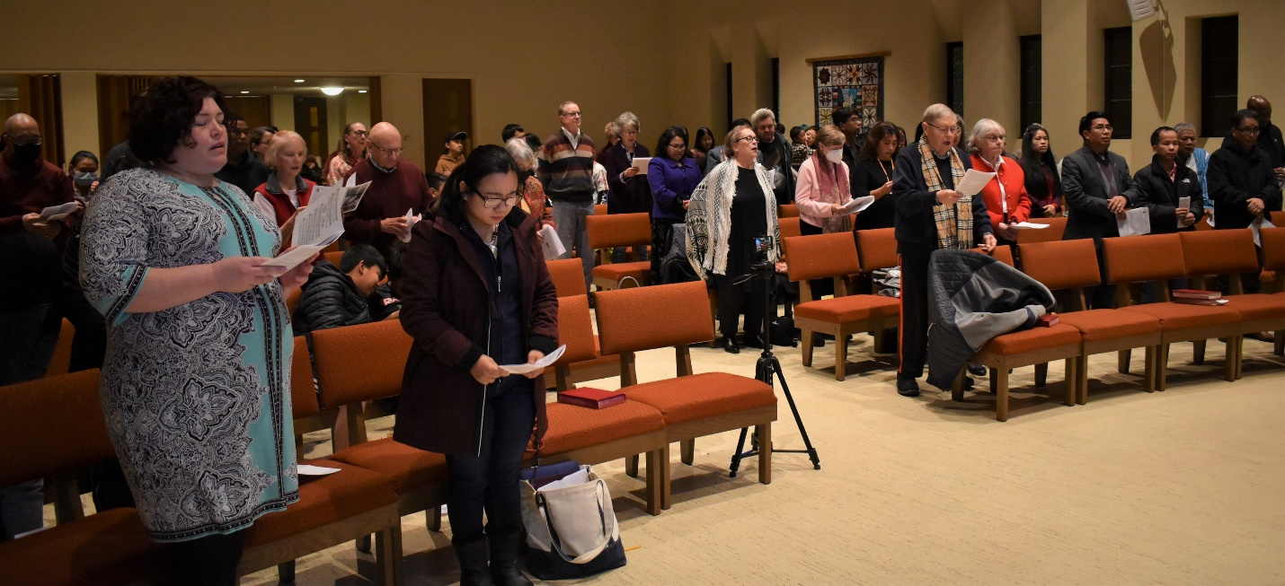

THIS HALLOWING PLACE
A sermon preached by
Rev. Dr. Randle R. (Rick) Mixon
Lake Avenue Baptist Church, Rochester, New York
Sunday, May 31, 2026

Text: Proverbs 8:1-14, 17-31 (NRSVUE)

Prayer: God of delight,
your Wisdom sings your Word
at the crossroads where humanity and divinity meet.
Invite us into your joyful being
where you know and are known
in each beginning,
in all sustenance,
in every redemption,
that we may manifest your unity
in the diverse ministries you entrust to us,
truly reflecting your triune majesty
in the faith that acts,
in the hope that does not disappoint,
and in the love that endures. Amen.

Hallowing – there’s a word we rarely hear these days – unless, of course, you think I’m referring to that autumn occasion when costumed kids ring your doorbell and demand “trick or treat.” However, that word is spelled differently. There is a distinguishing bit of ring to “hallowing,” the word for today. “We are the people of God, come to this hallowing place…” My friend and mentor, David Bartlett, penned these words as a gift to the people of Lakeshore Avenue Baptist Church in Oakland. John Landgraf wrote the tune and labeled it “Lakeshore.” It was originally titled “Hymn for Pentecost” and became a kind of theme song for that congregation. I thought about using it last Sunday for Pentecost, but then I remembered what a thoroughly Trinitarian hymn it is. So, I saved it for today.

“Creator, strong and sure; Jesus, our friend and guide; Spirit and comforter…” each person of the Trinity is given due consideration in its own verse. The verses are lovely, but I especially like the chorus – “We are the people of God, come to this hallowing place. We are the body of Christ, bonded together by grace.” What a lovely, aspirational notion of what it means to be church – the body of Christ, bonded together by grace. It fits well with the call for us all to be the church together.

But what of “this hallowing place”? What does it mean to be “the people of God, come to this hallowing place”? David was a highly educated and cultured man; sometimes his vocabulary stretched beyond the ordinary. “Hallowing” – the dictionary says it means “to make holy or to consecrate.” Synonyms include to make sacred, to sanctify, and to bless. We are the people of God who come to this place that somehow makes us holy, that consecrates us, that sacralizes or sanctifies us, that both blesses us and creates us as a blessing. It’s an interesting and challenging thought, that this might be a “hallowing place.”

For other churches I have served, I have developed a strong belief in what I call “the ministry of the building. I wonder if that is not related to what might make a church a “hallowing place”? My friend, Don Ng, and I once had a spirited conversation about whether there can actually be a “ministry of the building.” He took the more conventional, non-liturgical view that a building itself cannot be sacred or a ministry. There must be sacred or sacralizing activity within it to create and sustain its mission. It’s the people who inhabit the space and what they do in it that sets it apart, that makes it a hallowing place. I understand this argument. There have been times when I have made it myself. In this regard, I am reminded of a Ken Medema song that sings, “Come build a church with soul and spirit…we need no tower rising skyward; no house of wood or glass or stone.” Of course, Ken is correct. We don’t have to have a building to be the church. Soul and spirit should be sufficient building materials.

But what do you do when you have a building? Well, not surprisingly, I do believe people can cultivate a “ministry of the building,” the church on the corner can become a “hallowing place,” a place where people can be made sacred, sanctified, blessed. There is an interaction between the holy and the human that can take place in a space that we call church that makes it a “hallowing place.” It is a mystery. I can’t fully explain how or why it happens, but I know it does.

More than one person who has entered this building and made use of it has sensed an aura about it that is hallowed. They may not be here at all for spiritual or religious reasons. Yet, once they enter the space, they experience something unique that is inherently spiritual – even when the congregation is not present. It makes the building itself attractive, a place where people want to linger, a hallowing place. Yes, it’s a lovely space, but the hallowing dimension is more than that. Maybe it’s the cloud of witness that hovers within the walls. Maybe it’s the efforts that have been made here over the past 155 years to worship, witness, learn, and grow God’s Beloved Community. Maybe it’s the faithful commitment of a people to God and to the gospel and to the well-being of one another and the wider community and all creation. Some combination of these things and more makes this a hallowing place.

Now I know this is Trinity Sunday. We have acknowledged that in our music and liturgy. But I want to suggest that today’s text invites us to consider also “Quaternity.” Proverbs argues persuasively for a fourth person in the Godhead, that of Sophia or Holy Wisdom, a feminine image without question. In our own time, Carl Jung has made a similar argument for a feminine fourth face for the Holy. But Christians through the centuries have not been quick to embrace any feminine face for God, though we sometimes affirm that both the Hebrew and Greek words for Spirit have female roots. Of course, we also know that anything we say about God is inherently limited. There is always more, God as “the More.” So, it seems significant that the lectionary gives us this ancient, challenging word on a day traditionally reserved for the Trinity.

Following today’s text, could we argue that this is a hallowing place because over the years room has been made here for Holy Wisdom? Is this a place in which Wisdom has been allowed to call, to raise her voice, a place where she can take her stand and cry out? “To you, O people, I call, and my cry is to all that live. O simple ones, learn prudence; acquire intelligence, you who lack it. Hear, for I will speak noble things, and from my lips will come what is right; for my mouth will utter truth; wickedness is an abomination to my lips. All the words of my mouth are righteous; there is nothing twisted or crooked in them. They are all straight to one who understands and right to those who find knowledge.”

Of course, we haven’t always paid attention and allowed her to guide us. But perhaps we have been attentive enough and willing to follow to the degree that we at least recognize this as a hallowing place in which God’s people are sometimes present and working to bring about God’s Beloved Community. Here, on occasion, we have encountered Wisdom, gained knowledge, learned prudence and discretion, acknowledged, in awe, the Holy One, laid aside pride and arrogance and gained insight and strength. Isn’t this what hallowing is all about and why we come here week after week, seeking the sacred at some level, obvious or hidden? I believe it is.

In a reflection entitled, “A Desperate Need for Wisdom,” Hebrew Scripture scholar, John Holbert, rants, “I gaze with mounting horror at the ill-mannered, rude, crude ad hominem nonsense that exudes at great lengths from the keyboards of literally thousands of phones and pads and computers. Hundreds of comments ensue, many building on the foolishness of previous ‘authors’ (I debase the term to name such drivel so) until any hope of enlightenment is drowned, buried, exploded in a maelstrom of vitriol and a spasm of words vomited from a very dark chasm of some verbal hell. I pile on the multiple metaphors for the reason that the social media frenzy does the same, cascading a waterfall of gibberish onto the floors of unsuspecting platforms, swamping gigabytes and terabytes with hogwash by the ton” (John C. Holbert, “A Desperate Need for Wisdom: Reflections on Proverbs 8,” The Peripatetic Preacher, May 16, 2016, patheos.com)

Apparently, Hobert has strong feelings about the way of the modern world! Maybe you do, too. I know I feel that way when I read the screeds and rants and untruths unloaded day and night by the current occupant of the White House. Holbert’s essay was penned in 2016. I wonder how his feelings of disdain and disgust might have intensified, if possible, over the past ten years? If he felt desperate for wisdom then, how much more must he feel that today? Hyperbole aside, he has a legitimate point. In so many ways, our contemporary society has abandoned Wisdom and gone off in search of the lowest possible denominators of social enterprise imaginable. In fact, some defy imagination and now threaten our very existence.

We are under assault from lies and misrepresentations in the highest seats of power. It is hard to hear truth and recognize righteousness. Empathy is a sin and compassion is a liability. As democracy in this country is at increasing risk of failing, my friend Jim Hopkins reminds us that “an authoritarian government comes with very high costs to liberty, justice, charity, equality and opportunity.”

Holbert is right. There is a desperate need for Wisdom. Too often today, she stands on the heights, beside the way, at the crossroads, beside the gates in front of the town, at the entrance of the portals, crying out and no one pays her the least attention. More often than not, we are too busy, preoccupied, hardened against her message, to pay attention to her cry. We are deaf to her voice. We are eagerly on our way somewhere else; we are not interested in looking for or finding her hallowing place. We pass quickly by on the other side. Friends, we do so at our own peril.

Still, there is good news. Holy Wisdom, born of God, architect of the created order, she who has dwelt beside God from the beginning, has been God’s daily delight, rejoicing before God always, rejoicing in God’s inhabited world, even delighting in the human race, is not going away. She has been ignored, reviled, and abused before, and, undoubtedly, she will be again. Nevertheless, she persists. She perseveres, offering her gifts in the same vein God offers grace – abundantly, infinitely, to the end of time and beyond. The day will come when “the earth will be full of the knowledge of the Holy One as the waters cover the sea” and all of creation will be recognized as hallowing space.

Until then, the people of God need places like this, and others we will discover in the days ahead, which are hallowing places, places in which we might discover Wisdom, embrace her and learn her ways. With John Holbert we may yet pray, “’Come quickly, [Woman] Wisdom,’ and clear our minds of foolishness, cleanse our mouths from stupidity, make our words and work with one another worthy of the high calling of God to love and care for all of God’s vast and rich creation” (Holbert, op. cit.). Thanks be to God for all the ways and all the days in which this has been a place where Wisdom is welcomed, a hallowing place. As we continue to care for this hallowed place, may we also find and build up other hallowing places on our journey as people of God, the body of Christ, bonded together, if not in person, then surely in grace. Amen.

