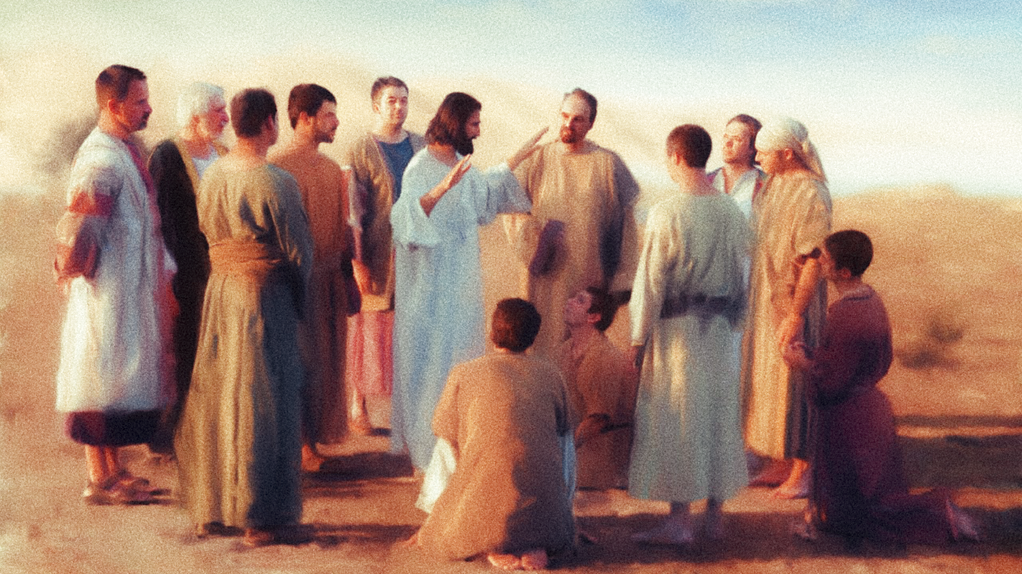

FOLLOW DIRECTIONS
A sermon preached by
Rev. Dr. Randle R. (Rick) Mixon
Lake Avenue Baptist Church, Rochester, NY
Sunday, June 14, 2026

Text: Matthew 9:35-10:1, 5-15 (The Message)

Practically all my life, I have sung in choirs. With a few exceptions, it’s difficult to produce good choral music without some sort of direction. The best directors have an overarching conception of what the music should sound like and how it might communicate to those who listen. In order to achieve these goals, directors must also understand the gifts and limits of their singers and all the many nuances involved in shaping the music just so. If you are a singer in the choir, you must learn to and commit yourself to following the director and their directions if you want to make beautiful music. Otherwise, the whole thing falls apart with chaos and consternation as the result.

In today’s text, Jesus functions as a sort of master director, choosing his singers from among ordinary folk with a capacity to make music together and giving them the directions they need to produce the amazing music of God’s inbreaking Beloved Community. In addition to learning the music for themselves they are also directed to recruit other singers for the choir, singers who will understand the mission and grasp its goal of well-being for all. Not everyone invited will choose to join, but it is vital that the good news be spread and the invitation offered. Jesus can only do so much. Others are needed to join the choir and make sweet music. There are seats beyond imagining in the heavenly choir.

So, what is the music, the mission? Matthew begins by summarizing what Jesus has been up to. “…Jesus made a circuit of all the towns and villages. He taught in their meeting places, reported kingdom news, and healed their diseased bodies, healed their bruised and hurt lives.” It’s a concise account of what we might call the “Jesus Song.” Among other things, the “Jesus Song” is deeply rooted in compassion. “When he looked out over the crowds, his heart broke. So confused and aimless they were, like sheep with no shepherd.”

In the early days of his ministry, as Jesus moved around his home territory of Galilee, his preaching and teaching and healing and exorcising and feeding the hungry have understandably drawn increasingly large crowds. People are hungry and thirsty for what he has to offer, and he sees their need reflected in both the desperation and hope in their eyes. However, as the crowds grow and the needs accumulate, it is clear that one man, not even Jesus cannot do it all. He needs help.

“What a huge harvest!” he says to his disciples. “How few workers! On your knees and pray for harvest hands!” He speaks to those who have followed him most closely as he has moved through their towns and villages, especially to those whom he has invited to follow and have said “yes.” The “Jesus Song,” the music of heaven, the mission of the Beloved Community needs more members, more witnesses. The irony of the way Matthew frames the expansion is that it begins with Jesus directing the disciples to their knees in prayer, but it does not end there.

I’m sure you have heard complaints about those who turn quickly to “thoughts and prayers” and stop there. You may have raised that concern yourself. If the disciples stay on their knees in prayer is anything likely to change? Not in this scenario. “The prayer was no sooner prayed than it was answered. Jesus called twelve of his followers and sent them into the ripe fields. He gave them power to kick out the evil spirits and to tenderly care for the bruised and hurt lives.” I imagine Jesus knew full well that the answer to their prayers would actually be the disciples. They themselves are the “harvest hands” that are wanted and needed, the musicians that will fill the choir loft, the witnesses that will build up God’s Beloved Community. Prayers need hands and feet along with heads and hearts as Jesus himself.

And it is them largely because they are the ones who have been traveling with Jesus, listening to him, watching him, immersed in the “Jesus Song.” At one level, Jesus has chosen these precisely in order to teach them how to do what he has been doing and what will be needed going forward until the final chorus is sung, until God’s Beloved Community is established on earth as in heaven.

And so, the directions that they are to follow. I appreciate the way Eugene Peterson takes the ancient word and brings it to us in language that is familiar, that we can understand.

“Jesus sent his twelve harvest hands out with this charge:

‘Don’t begin by traveling to some far-off place to convert unbelievers. And don’t try to be dramatic by tackling some public enemy. Go to the lost, confused people right here in the neighborhood. Tell them that the kingdom is here.” This may be the most troubling of Jesus’ directions here, but scholars remind us that Jesus was a Jew who had lived most of his life in Galilee. So, it should not be altogether surprising that he begins his budding movement at home. Don’t overextend yourselves, he cautions. Do the work that is right in front of you with the people you can reach.

For Jesus, this is a starting point. He has already communicated that the Good News is not ultimately limited to their close neighbors. He has shown and will again show compassion toward Gentiles who come to him in need of what he has to offer. But for this moment the starting point is limited to what is realistically manageable. As the community continues to grow, we will hear him in the end of Matthew’s story, the director directing the choir to “Go out and train everyone you meet, far and near, in this way of life, marking them by baptism in the threefold name: [Creator, Christ,] and Holy Spirit. Then instruct them in the practice of all I have commanded you. I’ll be with you as you do this, day after day after day, right up to the end of the age” (Matthew 28:19-20 The Message). “Invite everyone and anyone to join the choir and sing my song.”

Then there are further directions – “Bring health to the sick. Raise the dead. Touch the untouchables. Kick out the demons. You have been treated generously, so live generously.” These are the same things they have watched Jesus model for them. Now he gives them the authorization and opportunity to do likewise.

Oh, and by the way, “Don’t think you have to put on a fund-raising campaign before you start. You don’t need a lot of equipment. You are the equipment, and all you need to keep that going is three meals a day. Travel light.” Now there’s a challenge for those of us encumbered with so much stuff. I imagine those first followers who didn’t have much to begin with, did not find this direction too difficult, compared to what it might cost us to “travel light.”

And finally, “When you enter a town or village, don’t insist on staying in a luxury inn. Get a modest place with some modest people and be content there until you leave.

“When you knock on a door, be courteous in your greeting. If they welcome you, be gentle in your conversation. If they don’t welcome you, quietly withdraw. Don’t make a scene. Shrug your shoulders and be on your way. You can be sure that on Judgment Day they’ll be mighty sorry—but it’s no concern of yours now.” Interesting that these witnesses are to be gentle and gracious and not contentious in their dealings with others. Offer the Good News with good will and good grace. Give those who will listen time and space to find their way. This is the work of faithful witness. You can’t make people sing a song they don’t want to sing, even if it is the “Jesus Song.”

Now here’s the thing. That was then but this is now. What about us? Is this just a moving story about something that happened long ago? Is it a song we love to hear but don’t know how to sing? Is it a song we sing but are unwilling or unprepared to share? Last week we sang John Bell’s compelling song, “The Summons.”

Will you come and follow me if I but call your name?

This must be something like the song Jesus sang to his first followers. Can you hear him singing it now to you? Will you come and follow me? The harvest is still huge and the workers are few! If we hear and answer “yes,” I imagine the directions for us will not be much different than for those long ago. Develop your sense of compassion. “Bring health to the sick. Raise the dead. Touch the untouchables. Kick out the demons.” Practice generosity. Comfort the bruised and battered, accompany the lonely and wandering. “Go to the lost, confused people right here in the neighborhood.” The “Jesus Song” for us, complete with directions. As disciples, as faithful followers, as singers in the choir we are authorized to go make mighty music in Jesus’ name and with his promise to be with us until the “Jesus Song” is sung everywhere.

Will you come and follow me if I but call your name?
Will you go where you don’t know and never be the same?
Will you let my love be shown, will you let my name be known?
Will you let my life be grown in you and you in me?

